# Set up the Tableau Workspace for data analysis

**Screenshots of work**

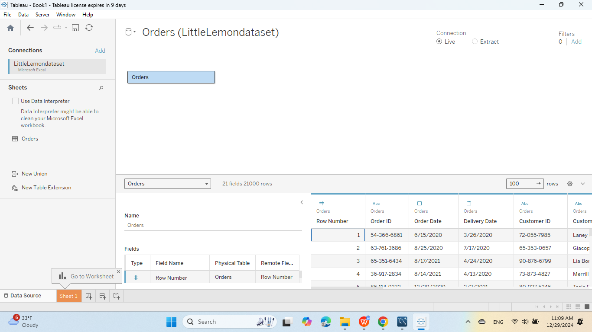

Task 2

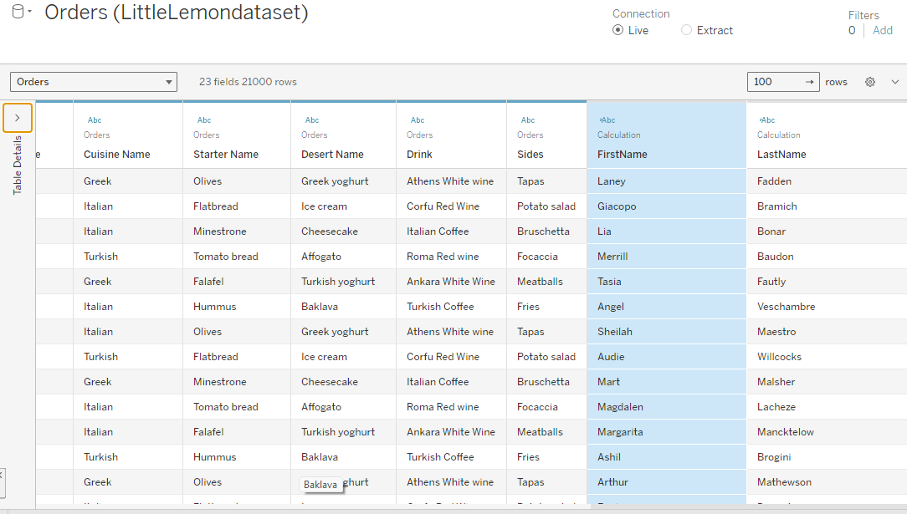

TASK 3

